NAME : TUSHAR
ROLL NO : IT-A-01

EXPERIMENT 1

What is an Operating System?
An Operating System (OS) is system software that manages computer hardware, software resources, and provides services to computer programs. It acts as an interface between user and hardware.

Study of Different Operating Systems
UNIX
- Developed in 1969 at AT&T Bell Labs
- Multi-user, multitasking OS
- Mostly used in servers and research
- Command-line based
- Very stable and secure
Linux
- Developed by Linus Torvalds (1991)
- Open-source OS
- Free to use
- Supports GUI + CLI
- Used in servers, mobiles (Android), supercomputers
Windows (XP / 7 / 8)
- Developed by Microsoft
- GUI-based OS
- Easy to use
- Popular for personal computers
- Supports many applications and games
Program 1: Process Management (fork, getpid, wait)
#include <iostream>
#include <unistd.h>
#include <sys/wait.h>

using namespace std;

int main() {
pid_t pid;

pid = fork(); // create new process

if (pid == 0) {
// Child process
cout << "Child Process ID: " << getpid() << endl;
}
else {
// Parent process
wait(NULL); // parent waits for child
cout << "Parent Process ID: " << getpid() << endl;
}

return 0;
}
OUTPUT :
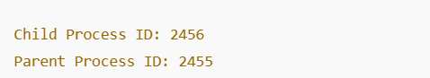

Program 2: File Management (open, write, read, close)
#include <iostream>
#include <unistd.h>
#include <fcntl.h>
#include <cstring>

using namespace std;

int main() {
int fd;
char buffer[100];

// Create and write to file
fd = open("oslab.txt", O_CREAT | O_WRONLY, 0644);
write(fd, "UNIX File Management System Call\n", 34);
close(fd);

// Read from file
fd = open("oslab.txt", O_RDONLY);
read(fd, buffer, sizeof(buffer));
close(fd);

cout << "File Content: " << buffer << endl;

return 0;
}
OUTPUT:
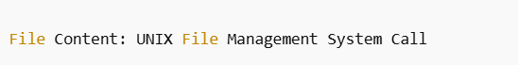

Program 3: Input / Output System Calls (read, write)

#include <unistd.h>

int main() {
char msg[] = "Hello OS Lab using I/O system calls\n";
write(1, msg, sizeof(msg)); // write to stdout
return 0;
}
OUTPUT:
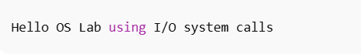
EXPERIMENT -2

2.1 SHORTEST JOB FIRST (SJF – Non-Preemptive)
#include <iostream>
using namespace std;

int main() {
int n;
cout << "Enter number of processes: ";
cin >> n;

int at[n], bt[n], wt[n], tat[n];
bool done[n] = {false};

for(int i=0;i<n;i++){
cout << "Enter Arrival Time and Burst Time of P" << i+1 << ": ";
cin >> at[i] >> bt[i];
}

int time = 0, completed = 0;
float avgWT = 0, avgTAT = 0;

while(completed < n){
int idx = -1, minBT = 9999;

for(int i=0;i<n;i++){
if(at[i] <= time && !done[i] && bt[i] < minBT){
minBT = bt[i];
idx = i;
}
}

if(idx == -1){
time++;
} else {
time += bt[idx];
tat[idx] = time - at[idx];
wt[idx] = tat[idx] - bt[idx];
done[idx] = true;
completed++;
avgWT += wt[idx];
avgTAT += tat[idx];
}
}

cout << "\nProcess WT TAT\n";
for(int i=0;i<n;i++)
cout << "P" << i+1 << " " << wt[i] << " " << tat[i] << endl;

cout << "\nAverage Waiting Time = " << avgWT/n;
cout << "\nAverage Turnaround Time = " << avgTAT/n;

return 0;
}
OUTPUT:
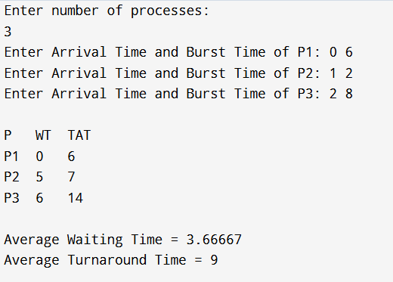

2.2 PRIORITY SCHEDULING (Non-Preemptive)
#include <iostream>
using namespace std;

int main() {
int n;
cout << "Enter number of processes: ";
cin >> n;

int at[10], bt[10], pr[10], wt[10], tat[10];
bool done[10] = {false};

for(int i=0;i<n;i++){
cout << "Enter AT, BT and Priority of P" << i+1 << ": ";
cin >> at[i] >> bt[i] >> pr[i];
}

int time = 0, completed = 0;
float avgWT=0, avgTAT=0;

while(completed < n){
int idx = -1, highP = 9999;

for(int i=0;i<n;i++){
if(at[i] <= time && !done[i] && pr[i] < highP){
highP = pr[i];
idx = i;
}
}

if(idx == -1) time++;
else {
time += bt[idx];
tat[idx] = time - at[idx];
wt[idx] = tat[idx] - bt[idx];
done[idx] = true;
completed++;
avgWT += wt[idx];
avgTAT += tat[idx];
}
}

cout << "\nP\tWT\tTAT\n";
for(int i=0;i<n;i++)
cout << "P"<<i+1<<"\t"<<wt[i]<<"\t"<<tat[i]<<endl;

cout << "\nAverage Waiting Time = " << avgWT/n;
cout << "\nAverage Turnaround Time = " << avgTAT/n;

return 0;
}
OUTPUT:
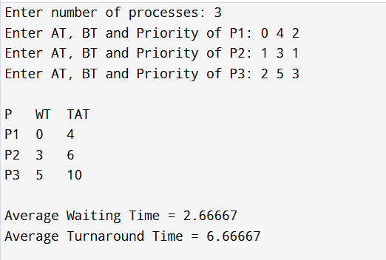

2.3 FCFS (First Come First Serve)
#include <iostream>
using namespace std;

int main() {
int n;
cout << "Enter number of processes: ";
cin >> n;

int at[10], bt[10], ct[10], wt[10], tat[10];

for(int i=0;i<n;i++){
cout << "Enter Arrival Time and Burst Time of P" << i+1 << ": ";
cin >> at[i] >> bt[i];
}

ct[0] = at[0] + bt[0];
for(int i=1;i<n;i++)
ct[i] = ct[i-1] + bt[i];

float avgWT=0, avgTAT=0;

for(int i=0;i<n;i++){
tat[i] = ct[i] - at[i];
wt[i] = tat[i] - bt[i];
avgWT += wt[i];
avgTAT += tat[i];
}

cout << "\nP\tAT\tBT\tWT\tTAT\n";
for(int i=0;i<n;i++)
cout << "P"<<i+1<<"\t"<<at[i]<<"\t"<<bt[i]<<"\t"<<wt[i]<<"\t"<<tat[i]<<endl;

cout << "\nAverage Waiting Time = " << avgWT/n;
cout << "\nAverage Turnaround Time = " << avgTAT/n;
cout << "\nThroughput = " << (float)n/ct[n-1];

return 0;
}
OUTPUT:
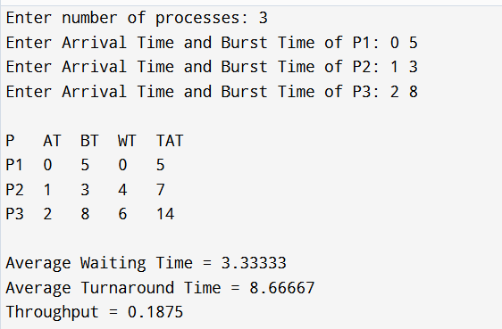

2.4 MULTI-LEVEL QUEUE SCHEDULING (Simple)
#include <iostream>
using namespace std;

int main() {
int n1, n2;
cout << "Enter number of System processes: ";
cin >> n1;
cout << "Enter number of User processes: ";
cin >> n2;

int bt1[10], bt2[10], time = 0;

for(int i=0;i<n1;i++){
cout << "Enter Burst Time of System P" << i+1 << ": ";
cin >> bt1[i];
time += bt1[i];
}

for(int i=0;i<n2;i++){
cout << "Enter Burst Time of User P" << i+1 << ": ";
cin >> bt2[i];
time += bt2[i];
}

cout << "\nTotal CPU Time = " << time;
cout << "\nThroughput = " << (float)(n1+n2)/time;

return 0;
}
OUTPUT:
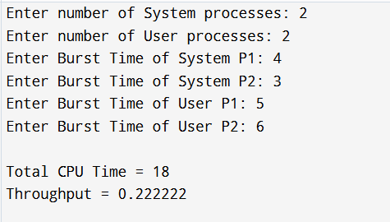
EXPERIMENT-3
In operating systems, file storage allocation techniques define how files are stored in secondary memory. The main strategies are:
- Contiguous Allocation:
Files are stored in consecutive memory blocks. It is simple and provides fast access but suffers from external fragmentation.
- Linked List Allocation:
Each file is a linked list of blocks, not necessarily contiguous. It solves the external fragmentation problem but requires sequential access to reach a specific block.
- Indexed (Indirect) Allocation:
A separate index block stores addresses of all file blocks. It allows direct access to any block and avoids external fragmentation.

1.Contiguous Allocation (Array)
#include <iostream>
using namespace std;

int main() {
int n; // total storage blocks
cout << "Enter total storage blocks: ";
cin >> n;
int storage[n] = {0};

int fileSize, start;
cout << "Enter file size to allocate: ";
cin >> fileSize;
cout << "Enter starting block: ";
cin >> start;

if (start + fileSize <= n) {
for (int i = start; i < start + fileSize; i++)
storage[i] = 1;

cout << "File allocated at blocks: ";
for (int i = start; i < start + fileSize; i++)
cout << i << " ";
cout << endl;
} else {
cout << "Error: Not enough contiguous blocks available.\n";
}

return 0;
}
OUTPUT:
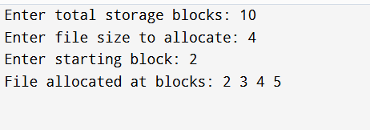

2. Linked List Allocation

#include <iostream>
using namespace std;

struct Node {
int block;
Node* next;
};

int main() {
int n, fileSize;
cout << "Enter total storage blocks: ";
cin >> n;
int storage[n] = {0};

cout << "Enter file size to allocate: ";
cin >> fileSize;

Node* head = nullptr;
Node* temp = nullptr;

for (int i = 0; i < n && fileSize > 0; i++) {
if (storage[i] == 0) {
Node* newNode = new Node;
newNode->block = i;
newNode->next = nullptr;
storage[i] = 1;
if (head == nullptr) head = newNode;
else temp->next = newNode;
temp = newNode;
fileSize--;
}
}

cout << "File allocated at blocks: ";
for (Node* ptr = head; ptr != nullptr; ptr = ptr->next)
cout << ptr->block << " ";
cout << endl;

return 0;
}

OUTPUT:
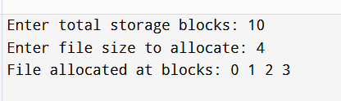

3.Indexed (Indirect) Allocation

#include <iostream>
using namespace std;

int main() {
int n, fileSize;
cout << "Enter total storage blocks: ";
cin >> n;
int storage[n] = {0};

cout << "Enter file size to allocate: ";
cin >> fileSize;

int indexBlock;
cout << "Enter index block: ";
cin >> indexBlock;

if (storage[indexBlock] == 0) {
storage[indexBlock] = 1; // index block occupied
int fileBlocks[fileSize];
int count = 0;

for (int i = 0; i < n && count < fileSize; i++) {
if (i != indexBlock && storage[i] == 0) {
storage[i] = 1;
fileBlocks[count++] = i;
}
}

if (count == fileSize) {
cout << "File allocated using index block " << indexBlock << " at blocks: ";
for (int i = 0; i < fileSize; i++)
cout << fileBlocks[i] << " ";
cout << endl;
} else {
cout << "Error: Not enough free blocks.\n";
}
} else {
cout << "Index block already occupied!\n";
}

return 0;
}

OUTPUT:
